Example of Hankies sold on the web:
http://bumblebeelinens.com/personalized-four-lines-your-choice-hankie-font-p-609.html

Personalized Hankies
Mens Hankies are 45x45 cm and Ladies 30x30 cm
Tread Colours to choose from: (scorll over picture to enlarge)
Lt Blue | Blue | DK Blue | Turqoise
Lt Lavendar | Lavendar | Purpel | DK Purple
Lt Pink | Pink | DK Pink | Cherise Pink
Red | Orange | Green | Olive
Aqua | Cream | Brown | DK Brown
White | Grey | Charcoal | Black

Availabe Options:
Message: 200 chars left (spaces included)
Additional: 25 chars (+R20.00)
Additional: 25 chars (+R20.00)
Hanky Style:
Select Thread Colour:
Fonts:

Hankie Styles:
PH_01 | Personalised Ladies Hankie | R105
PH_02 | Personalised Men’s Hankie | R105
PH_03 | Personalised with Monograms | R105
PH_04 | Hankie Gift Box | R25

Fonts:
Font 1 | Font 2 | Font 3

Gift Boxes:
 |  | 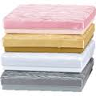
White Scrolls | Block Box with Scrolls | White Satin Boxes
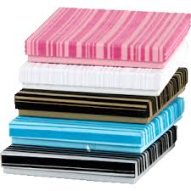
White Stipes – embossed | White box with bling dots | White and Grey polka dots

Please note – patterns may differ

Scrolls:
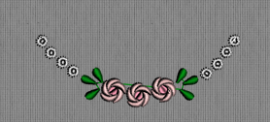 | 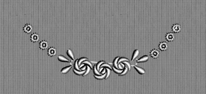
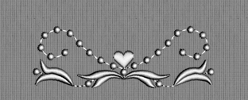 | 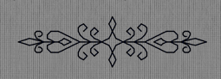
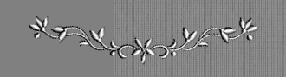 | 